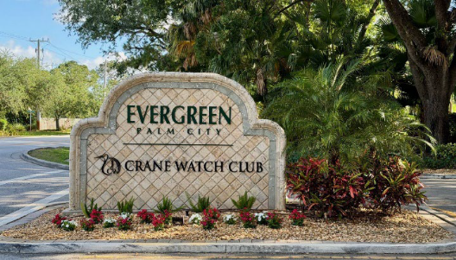

Front Entrance Paver Repair Update
Dear Evergreen Residents,
The Board of Directors has reviewed the proposals received for repairs to the visitor side of the front entrance and has selected Apex Pavers to complete the project.
Apex Pavers submitted the lowest proposal at $2,400. Nick Manolis has indicated that he plans to bring additional crew members to the project, with the goal of completing the work in approximately 4–6 hours on a Saturday morning.

Vendor Quotes Reviewed
Vendor | Contact | Proposal
Apex Pavers | Nick Manolis | $2,400
Beachside Pavers | Maria Carreno | $3,376
Elite Design & Pavers | William Torres, Owner | $4,200
The repair will require the visitor entrance to be temporarily closed while the work is being completed.
The Board will coordinate closely with Apex Pavers, along with Gary and Daniel on the security side, to establish the work schedule, manage traffic, and minimize disruption to residents and guests.
Once the project date has been confirmed, we will provide the community with advance notice, including any temporary entrance-access instructions.
Thank you for your patience and cooperation as we complete this important repair and continue working to maintain and improve Evergreen’s common areas.
Evergreen Association
Board of Directors

