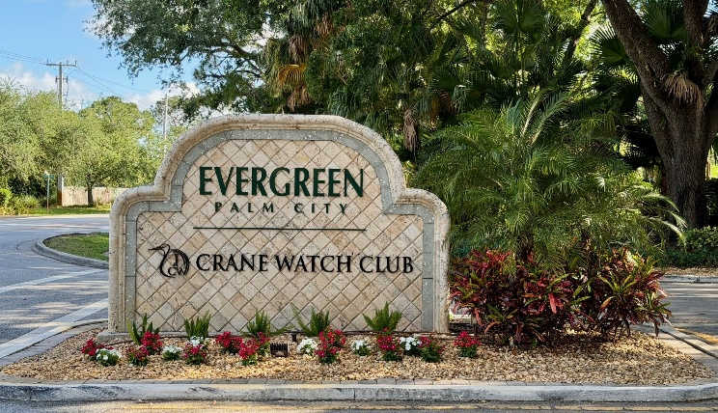
Subject: Evergreen 2026 Holiday Lighting – Vendor Selection & Community Update
Dear Evergreen Residents,
The holiday season will be here before we know it, and the Evergreen Board of Directors is excited to share an update regarding the community’s 2026 Holiday Lighting Program.
As part of the Board’s continued effort to obtain competitive pricing and carefully review Association expenditures, we solicited proposals from several professional holiday lighting companies for the front entrance, guard house, oak trees, monument, and interior flagpole area.
The proposals varied considerably in both design and scope, so they were not direct apples-to-apples comparisons. Pricing ranged from approximately $7,954 to $25,040, with different levels of tree lighting, spritzer decorations, monument lighting, guard house lighting, and interior flagpole/intersection-area lighting.
The following vendors submitted proposals for Evergreen’s 2026 holiday lighting:
- Randy’s Holiday Lighting: $7,954.49
- Holiday Seasonal Lights: $8,810.00
- Griswolds Christmas Lights: $12,852.00
- North Pole Holiday Lighting: $14,849.51
- Holiday Outdoor Décor: $25,040.00
After reviewing the proposals, pricing, proposed designs, service commitments, and overall scope of work, the Board selected Holiday Seasonal Lights for Evergreen’s 2026 Holiday Lighting Program.
Holiday Seasonal Lights submitted a standard project value of $8,810.00. The Board was able to negotiate a 10% discount, bringing Evergreen’s 2026 contract amount to $7,929.00.
Importantly, the Board was also able to negotiate a one-year trial agreement for 2026 rather than immediately committing the Association to a long-term contract. This gives the Board and membership an opportunity to evaluate the quality of the installation, overall presentation, maintenance, and service throughout the season. If the Board and Association membership are satisfied with the results, the Association can then consider entering into a three-year agreement with Holiday Seasonal Lights beginning with the 2027 holiday season.
The agreement includes professional installation and wire management, in-season maintenance and service calls, post-season removal, and organized storage of the lights, displays, and equipment.

What Residents Can Expect:
The new holiday display will focus on creating a warm, elegant look using commercial-grade warm white LED lighting throughout key areas of Evergreen.
At the main entrance, the trunks of the six large oak trees will be wrapped approximately 11–13 feet high with commercial-grade warm white LED lights. The design will also include 48 warm-white spritzer decorations suspended throughout the oak branches above the driveway and guard house area.
The guard house will have its upper perimeter outlined with warm-white holiday lighting. Additional holiday lighting will also be installed at the interior flagpole/intersection area, providing holiday décor beyond just the community’s main entrance.
The package is designed as a turnkey service, meaning Holiday Seasonal Lights will be responsible for the professional installation, in-season maintenance, removal, and storage of the holiday lighting and equipment.

Installation & Turn on Dates:
Holiday Seasonal Lights is currently scheduled to begin installation on October 24, 2026.
Residents may begin seeing crews and equipment around the front entrance and other designated common areas as the holiday display is installed. The lights will remain off following installation until the official start of Evergreen’s holiday season.
We are excited to announce that Evergreen’s holiday lights will officially be turned on Thursday, November 19th!
The Board would like to thank all of the vendors who took the time to visit Evergreen, evaluate the property, develop designs, and submit proposals for consideration. We also appreciate the membership’s continued support as we continue looking for opportunities to enhance our community while remaining mindful of Association expenses.
For complete transparency, Association members may review the individual vendor proposals and additional information regarding the selection process on the Evergreen Association website under the Notifications section. Please look for the post titled “Evergreen 2026 Holiday Lighting – Vendor Selection & Community Update.”
We encourage residents who are interested in the details of the project to review the proposals and see the different designs, scopes of work, and pricing options that were considered by the Board.
We look forward to lighting up Evergreen and kicking off the holiday season together!
Thank you,
Evergreen Board of Directors

