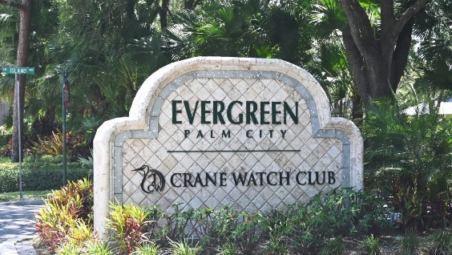

To: All Evergreen Property Owners
From: Tony Kretz, Evergreen Board of Directors President
Re: Evergreen Storm Water System Improvements Update)
Date: February 12, 2026
Residents,
Happy Thursday! Sunshine Land Design has completed work along Island Way and has begun the second section of the first phase of the project. The team is currently located along the bend on by 5200 area of Bimini North. The team started last Friday and installed a new drainage box near the pond that runs along hole 4 at Crane Watch. This week, they will start reforming the swale from the golf course to the Bimini Circle N.
Once completed, they will begin work on the common-area swales, extending them up to 150ft or more from the main drainage swale. If a property owner would like their culvert assessed or cleaned out, please let Sunshine know, and they will gladly assist. The culvert needs to be cleaned out to improve water flow.

If your culvert needs cleaning. The property owner is responsible. You may do the work yourself, hire a different vendor, or have Sunshine complete it for $80. If you choose Sunshine to complete the work, you will need to set up a time with them and pay them directly. If they want to clean on their own, it must be completed before Sunshine installs sod.
Secondly, Sunshine Land Design requests permission to operate its sprinkler systems to ensure that any necessary repairs in the R.O.W. are completed. If a property owner does not want Sunshine Land Design to operate their sprinkler system, the property owner must turn it on while our technician is present to verify that everything is flushed and repaired. Note that all of our work will be done only in maintenance easements.
We thank the community for their continued patience as we work through this project. If you have any questions about Sunshine Land Design maintenance, please contact them directly. They will call you back by the next business day. They can be reached at (772) 283-2648 and ask for either Tim Taylor or James Brockmeirer.
Kind Regards,
Tony Kretz
Evergreen Board President

