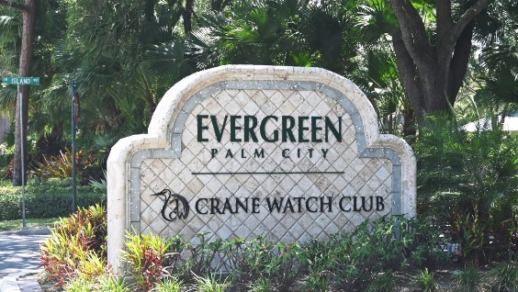
To: All Evergreen Property Owners
From: Tony Kretz, Evergreen Board of Directors President
Re: Evergreen Storm Water System Improvements
Date: January 5th, 2026

Residents:
Happy New Year and 2026! Back in October of 2025, the current Board of Directors, during a special meeting, approved hiring Tim Taylor of Sunshine Land Design to improve the Evergreen Community's Storm Water Drainage. As part of that meeting, I mentioned I would be transparent with all property owners in the association about the steps being taken, when and where they would be completed, and how this would be completed.
After a few back-and-forth meetings, we put pen to paper, and the first phase of the drainage project will start within the next week. There will be six main areas that will be the Phase 1 priority. These areas will include the following:
- Island Way, (18 A & B)
- 5185 Bimini South, (PR-43)
- 5222 SW Bimini North Drain Easement (Item 8)
- 4842 SW Bimini North Drain Easement, (6 A & B)
- 5272 SW Bimini North Drain Easement
- 4396 SW Bimini South Drain Easement (3 A & B)
Phase One will begin with Island Way the week of January 5^{th,} 2026. The first phase of Island Way will include land survey along the road and culverts of those properties located along this street. Once surveys are completed, Sunshine Land Design will notify the Board of Directors and Coastal Property Management of the culverts Sunshine Land Design recommends be cleaned out. Please be mindful that not all culverts may need to be cleaned out. If property owners need culverts addressed, Sunshine will complete the work for $80 per culvert. This will be the homeowner's responsibility.
Sunshine will provide any additional recommendations at the time of evaluation. We ask that the property owners communicate with Sunshine directly if any recommendations are given. Property owners may choose to use Sunshine to complete any suggested recommendations, use their own vendors, or complete the work themselves.

Owners where swales and culverts will be reviewed will receive a separate email from either Angelo Palmieri or me regarding the steps that will need to be taken prior to Sunshine starting in various locations. The goal is to have these emails out no later than a week before they start work in your area. If you have any questions or concerns, please send them directly to Sunshine Land Design. We will have the project manager's contact information in the email that will be sent out.
Each phase will take roughly 3-4 weeks to complete, with Phase 1 being completed before June 2026. After Phase 1 is completed, the Board of Directors, Coastal Property Management, and Sunshine Land Design will re-evaluate the next steps. We are asking all residents during this time to please be mindful of any work being done on the property.
Finally, as mentioned in the October 2025 meeting, this Phase will be fully paid from the association's reserves. We have worked out payment terms with Sunshine, which will not affect some of our current CD and money market accounts. This way, we can continue to let that money grow. However, please be mindful that, with current budget meetings for 2026-27, there may be a monetary increase to fund other improvements around the community. These terms are noted in the attached executed proposal email.
Lastly, this email includes four attachments for complete transparency. One will consist of pictures of the areas to be addressed in Phase 1, the signed proposal between the Board and Sunshine Land Design, a matrix review conducted at the start of the 2023 drainage project, and an overall snapshot of the areas reviewed during the 2023 evaluation. In the coming days, the Board will also update the Evergreen website (www.evergreenpoa.com) with all the contact information. The website will also include additional details, completed by the Board of Directors, that began this initial project in 2023, to give property owners a full scope of the information. We will add additional legends so everyone has a clear idea of what they are looking at.
We understand there will be some questions and concerns over this project. As mentioned, this will take some time to navigate, but stormwater drainage has been a major issue over the last couple of years, and it is now starting to affect our roads. However, before we can address the streets, we need to get the infrastructure underneath fixed first. We appreciate everyone’s patience in advance as we navigate through this. We will continue to be as transparent as possible and answer any questions that you may have.
Thank you for your time and continued support!
Kind Regards,
Tony Kretz
Tony Kretz
Evergreen Board of Directors President
On Behalf of the Evergreen Board of Directors

