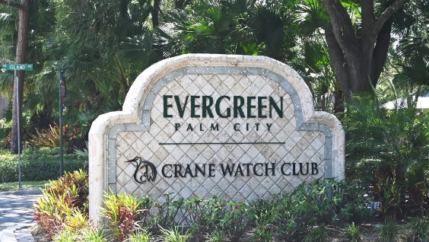
To: All Evergreen Property Owners
From: Tony Kretz, Evergreen Board of Directors President
Re: Evergreen Storm Water System Improvements Update)
Date: January 9th, 2026

Residents,

Happy Friday! As some of you seen, Sunshine Land Design has started their surveys along Island Way. The survey will be completed by the end of Friday, and construction of the new swales will begin in the morning. The reconstruction phase of this site will take roughly 2 weeks.

The next step for residents along Island Way. During the surveys, each property owner's driveway culvert was evaluated by one of the following. All is good; no additional action is needed. The culvert needs to be cleaned out to improve water flow, or a complete reconstruction may be needed. If you do not receive a call or email, no action is needed to be taken.

If your culvert needs cleaning. The property owner is responsible. You may do the work yourself, hire a different vendor, or have Sunshine complete it for $80. If you choose Sunshine to complete the work, you will need to set up a time with them and pay them directly. If they want to clean on their own, it will need to be done before Sunshine installs sod, which is scheduled for around January 19th, 2026. If your culvert needs to be completely redone, Sunshine can assist with the matter. Property owners may select their own vendor, but must complete it in a timely manner.
Secondly, Sunshine Land Design would also like permission to operate their sprinkler systems to ensure that any needed repairs in the R.O.W. are completed. If a property owner wishes Sunshine Land Design not to operate their sprinkler system, the property owner will need to turn it on when our technician is there to verify that everything is flushed and repaired. Note that all of our work will be done only in maintenance easements.
This will be the same process for each section completed in Phase 1 of the Stormwater Improvements. The Board of Directors understands all the various issues that some property owners have with their swales and drainage. As the Board of Directors and Sunshine continue to navigate the process, we ask for your patience as Sunshine reviews prior work from 2023. If anything needs to be addressed or a change is moved up the priority list, Sunshine will notify the Board of Directors or Coastal immediately. We only asked to contact Sunshine if you would like your culvert cleaned up. They will complete this action for $80 as well.
Lastly, there are some areas in Evergreen where pipes run underneath the roads. In some cases, the road is starting to become compromised. The Board of Directors and Sunshine are aware of these areas and will be completed with the guidance of Sunshine Land Design. Our first two areas of concern are on Bimini North. There will be two sections of road repaired.

The first section is by 5061 Bimini N., and the second section is just for each of those properties. These repairs will be completed on Friday, January 9th, and will take approximately 4 hours. The existing asphalt will be removed, new rock will be compacted around the pipe, and new asphalt will be laid. Sunshine examined both pipes in this area, and the pipes were still in good working condition. Each section will cost roughly around $2,000 to repair. These repairs will be paid out of the association's reserves.

If property owners have any questions or complaints, you may reach out to Jim Brockmeier, the current Project Manager at Sunshine Land Design, by calling the Sunshine Land Design office between 8 am and 3 pm at 772.283.2646. Please leave your name, address, and phone number to get back to you, and Jim will call you back at that number.

Thank you, everyone, for your continued patience in this matter. I know I have thrown a lot of information your way. We will continue to be transparent about the steps along the way. I have updated the website with all the maps and project information. Contact information will also be available on the website. You can access the website at www.evergreenpoa.com. We have a page dedicated to the Evergreen Stormwater System Improvement Project. You can access current information and previous information from the 2023 assessment.

If you have any additional questions, you can contact me or any member of the Board of Directors. We will try to get back to you promptly.

Have a great weekend!

Kind Regards,

Tony Kretz
Evergreen Board President
On Behalf of the Board of Directors

