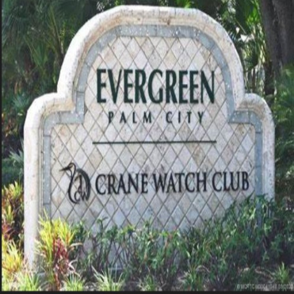
September 2025 President’s Newsletter:

- Coastal Property Management:
  - Please, if you have not done so, set up your online Vantaca account with Coastal Property Management. Members can access the website from this link: https://portal.cpmfl.com/. Vantaca will be the go-to source for all the information residents need. You can pay quarterly dues, submit ARC requests, view governing documents, and access a resident directory. The Board will continue to monitor and update the POA website.

- Amendment/Bylaw Proposed Changes:
  - All members should have received the proxy from Coastal Property Management regarding the proposed language changes to the amendments. It is a yes-or-no vote to accept or reject the new proposed language. The proxies are due back by Thursday, November 20th, or at the November Board of Directors meeting. The Evergreen POA website will have a section in the POA documents titled "Proposed Amendment Changes."

- Speeding:
  - Members, please slow down, please take the time to speak to your friends and vendors to make sure they are adhering to speed limits and stop signs. The road signs are not there for décor reasons. Evergreen has grown into a very family-oriented community. Now that school is in session, take the time and leave a little sooner. If you have any questions or suggestions on how to address the speeding issue, please contact a member of the Board of Directors or Angelo at Coastal Property Management.
- Crane Watch Club:
  - The Board has received some questions regarding Crane Watch being up for sale. Unfortunately, we know as much as everyone else does. Crane Watch has not presented any additional information to the Board beyond what is available online. For the first time in a while, the golf course is 100% compliant. However, due to other internal issues, we will not be rescheduling the meeting at the club anytime soon. Please continue to stay off the golf course unless you are actively playing golf; the course is private property.

- Safety:
  - The gate at Copperleaf: Members, if you have visitors come over from Copperleaf, they must follow the same rules and regulations. Back in June, I spoke with Ellsworth Clark (president of HOA for Copperleaf). Mr. Clark and I share similar feelings. Mr. Clark mentioned that he would ensure Copperleaf residents were reminded to stay off the golf course and to follow the rules of the road while visiting Evergreen. If there is any activity that doesn’t follow these Rules and Regulations, please contact Evergreen Security or the Martin County Sheriff's non-emergency line.

- Evergreen/Windstone Water Project:
  - Project Update: Main water pipes have been installed, and pressure testing has been completed. Within the next few weeks, they will start bacterial testing, which will take some time. Once Martin County has completed all the necessary steps, property owners will receive a letter from the county outlining the next steps.

  - On the community website, under POA Documents, there is a subsection “Evergreen/Windstone Water Project” where we have listed the primary two contacts from Martin County, essential documents, and a handful of vendors that have reached out to the Board of Directors who want to participate. Please note that we did not negotiate the price with any vendor.

  - Evergreen Guard House: The Board of Directors is in the process of reviewing bids to get city water installed at the Guard House. Currently, we have one quote from Jaime Underground for approximately $ 3,650. We have a few more vendors that have expressed interest in bidding on the project. Once we receive those quotes, we will post them to the community website for the community to review. We will highlight the one ultimately chosen.

- Guard House Software Update:
  - Over the last couple of months, JoAnn, Kevin, Joe, and Angelo have been a part of various meetings and demos to update our band-aided software security system. The feedback that I have received has been very positive. The Board of Directors has currently received a quote from Proptia/Star Technologies. We will receive a second bid from Butterfly Software Systems/Complete Access Systems in the coming days.

  - During the meeting, they discussed updating to an RFID system, upgrading software systems, installing new gate arms (as the current gates are no longer manufactured and repair parts are not readily available), and enhancing ease of use for both security staff and residents.

- Financials:
  - Currently, A/R sit just under $52k past due. For property owners who are past due, final notices were sent out to them last week.
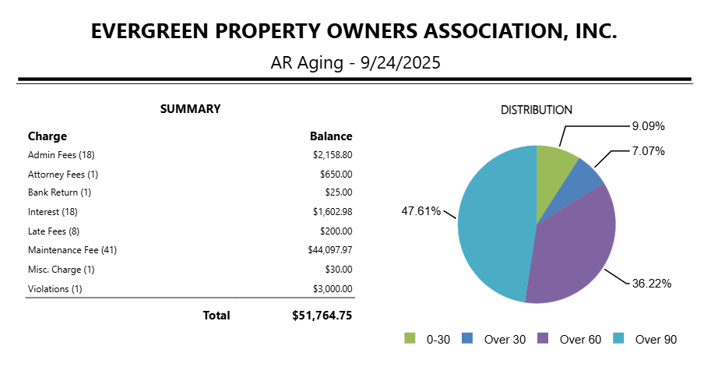

The current process that Coastal follows is below per the state of Florida Statute:

- Late Letter – A notice is sent to the owner advising them of their past-due balance, providing 30 days to bring their account current.

- Final Demand Letter – If full payment is not received by the due date, a final demand letter is issued, giving the owner 10 additional days to pay.

- Attorney Collections – If no payment is made, the account is automatically turned over to the association’s attorney for collection (i.e., lien & foreclosure).

- Inspections:
  - Coastal is on the property once a week, doing an inspection now. Notices and violations have gone out. Please let Coastal do its job. There is a protocol under the Florida statutes that they must follow when issuing violations and notices. Not everyone is perfect, so please be patient. The wheels are in motion, and Angelo will discuss this further in his manager's report—one area I would like to explore.

  - Under no circumstances can Coastal or Board go along the easements or the Golf Course to review houses for issues or violations. According to the rule and law, any violation must be observed from the front of the house. If any problem is sent to Angelo and is not visible from the front, please send the Board and Coastal the address and potential violation, and we will handle it internally.

  - Few thoughts, please address your landscape. If you have dead branches or palm fronds, consider hiring a professional landscape company to remove them. Please clean up the areas around your house, and refrain from parking your vehicles on the grass.

Inspection Report from September 25th, 2025:

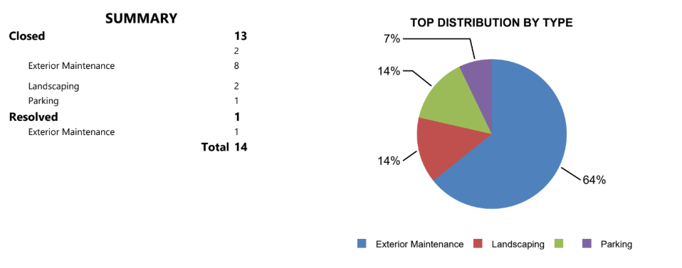
- Landscaping:
  - On September 6th, Evergreen had its first resident volunteer clean-up day at the front entrance. Personally, I don’t believe this could have gone much better than it did. Myself, JoAnn, Jennifer Caropino, the residents involved, and I couldn’t have been happier with the first work day. I personally can’t thank everyone who came out on that Saturday morning, some with their families, to pitch in for a couple of hours. Some people, including myself, got to meet our neighbors for a good cause.
  - Quick shout to some of the volunteers: Bosman Family, Cubby Family, Burns Family, Largent Family, Lucas Family, Kleinsmith Family, Unzula Family
  - The next clean-up will take place Saturday, October 11^{th,} from 8-12 pm in the front entrance. We will continue to work on the entrance side and the center of Evergreen.
  - Further steps will be the installation of rock and mulch in specific areas, painting of the retaining walls, and curbs.

- Other Agenda items:
  - We did have a resident reach out to the Board and Coastal Property Management regarding FPL and the fact that 45 homes do not have underground service. We are still investigating the issue and attempting to contact someone at FPL for assistance with the matter. Unfortunately, emails have not gotten anywhere. But we will keep trying.

  - Trunk or Treat: I would like to get a committee together and get some ideas regarding community involvement for Trunk or Treat this year. Last year, CWC took action independently of the Board's involvement. I want to plan something for the weekend before Halloween to kick off the holiday week. If you're interested in collaborating on this, please don't hesitate to contact me, and we can discuss some ideas. Residents will still be allowed to trick or treat on Halloween, but would like to have something fun to do as a community.

  - Holiday Lights: We will be using the same Holiday Light company for one more year. We are working to ensure we have the correct number of outlets to avoid overload and outages this year, as we have in the past. The installation date is October 23rd, and the lights will be turned on from November 20th through January 3rd or 4th.

  - The new Evergreen Flag is installed and looks awesome!

